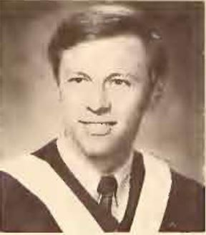 | 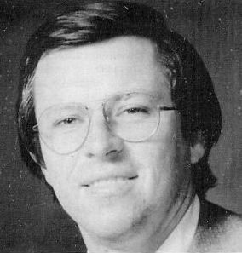 |  | 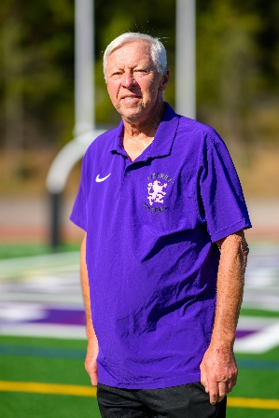
1969 | 1995 | 2008 | 2024

An Interview with Coach Mark A. Kliszewski
(“Coach K”)
By Jason Shum
Mark A. Kliszewski is known in Piedmont by two very different titles: Judge and Coach.
By profession, he has spent four decades in the law, serving since 1985 as a Juvenile Court Referee for the Alameda Superior Court. His guiding principle is simple but powerful: young people deserve guidance, not just punishment.
By passion, he is “Coach K,” a volunteer who has devoted thousands of hours to coaching youth sports, including football, basketball, baseball, softball, and soccer. His players know him not only as a coach but as a mentor who builds discipline, confidence, and teamwork.
His coaching journey began long before Piedmont. As a college student in 1967, he first coached middle school basketball, sparking a lifelong passion for mentoring kids. In Piedmont, he picked up baseball in 1982 and football in 1985, the same year his son Matt entered middle school. Since then, he has been a steady presence for local families, guiding young athletes and building connections that last well beyond the games.
Coach K’s personal story also speaks to service and character. Born in Overton, Wales, in 1949 to Polish parents, he came to the United States as a child. His mother was arrested during the Warsaw Uprising of 1944 while helping Jewish survivors and spent a year in a prisoner-of-war camp. His father fought with the British army and helped liberate concentration camps at the end of the war. After settling in Los Angeles, his parents became leaders in the Polish community, especially in Scouting and education, setting an example that shaped his own path.
His impact has been widely recognized. In 1986, the City of Piedmont named him Outstanding Volunteer for his service to youth, and in 1991, he received the Service to Youth Award from the Piedmont Council of the Boy Scouts of America and the Sidney C. Singer family. These honors reflect not only his dedication to the law and the playing field, but also his lifelong devotion to helping young people succeed.
How did you first get involved with Piedmont High School football, and what was the program like when you started?
Coach K: My son entered Piedmont Middle School as a pretty good football player. The head of the Rec Dept saw that, and, since a coach was needed for their teams, asked me to take on the 7th and then 8th grade teams. I did that for three years. Then Coach [Mike] Humphries, who was a good friend, asked that I join him in coaching the Freshman team at Piedmont High. I've stayed with one of the high school teams pretty much ever since.
What major changes have you seen in the football program over the decades—in terms of culture, coaching style, or player development?
Coach K: When I began, football was a big deal in Piedmont. We played in a very tough league, and always did well. We had 3 teams of up to 40 players on each. Varsity and JV practiced on the big field and frosh were on the baseball outfield. It was great for development, as kids would come in with virtually no knowledge or ability, and would be ready for varsity before junior year. The culture was great. Witter was pretty much packed every Friday home night, and a band and cheerleaders were always there. On Homecoming there'd be a parade around the field, a contest between classes for best float, announcement of homecoming king and queen, a huge rally in the gym, etc. Generally, Piedmont was the same over summers, with coaches trying to get players to come to practices, and Piedmont families travelling all over the place. Coaching went from very good to pretty bad, as coaches were paid very little, and some just weren't into it after a while. Our frosh program was great, because Mike Humphries stayed 48 years and I tagged along for 24.
How has the community's involvement or support for the football program changed over the years?
Coach K: Football has always been popular in Piedmont. There are fans, and they like to come out Friday nights and enjoy games. Teams were up and down most years, but community support has been pretty solid. Unfortunately, it has become difficult to get players to join the program. In the seventies and eighties, football was king. Since about 2010 there has been a slide. That can be attributed to several factors. Water polo and cross country have taken kids out of football to join their high school teams. Other season sports like basketball, lacrosse, swimming, baseball, etc. have attracted potential players to outside club teams who have insisted that they come to daily practices after school, thus eliminating them from football. Additionally, kids themselves, and oftentimes parents, have become very concerned about football injuries, and have opted not to play. And, of course, when COVID came along, football was very affected by the "no nearness" rules and barely hung on for three or four years. This is all exacerbated by the fact that there just aren't enough students at PHS to fill all the teams. Luckily, the program has made a big comeback in the last 2 years and there is good hope for a future rebound.
Are there any particular seasons or games that stand out to you as especially meaningful or memorable? Why?
Coach K: When I coached the frosh with Mike Humphries, we had an incredible run. We actually won 36 straight games over 5 years. This with a new class every season, and freshman players who had never played before entering high school. And we beat the cream of the crop around the Bay Area. It was truly wonderful and eventually led to some terrific varsity teams.
How has the role of student-athletes changed at Piedmont, especially when it comes to balancing academics and athletics?
Coach K: I don't believe that the student athlete has changed much. Piedmont students have always done very well academically, with many on the honor roll and having great success in school and in life. There are always some knuckleheads, but no one has been extraordinarily bad, and many have been very successful.
What are some of the biggest challenges the program has faced, and how did the team overcome them?
Coach K: The COVID crisis of 2019-21 was very difficult. We were unable to play football. We could line up and run plays with our masks on, but we couldn't get close to each other, or even use a ball. Practices were pretty ridiculous and players began to stop coming. We only had about 15-18 players on varsity so games were almost impossible to play. JV had about the same numbers. After 5 games varsity had to give up its season. Luckily, many of the varsity players were sophomores, so they were placed on JV and we managed to complete the JV season. That kept kids playing and did a lot to save football in Piedmont.
What values or lessons do you hope players take away from being part of the Piedmont football program?
Coach K: Football is a pretty unique sport. All 11 players on the field have to be in sync for there to be success. If one player does the wrong thing, a play falls apart. This is a great lesson for life. Coordinating with other people, helping when someone needs help, working together towards a common goal, befriending others whom you may not know, all qualities that are begun in, and carried forward, from football. Also, hard work is learned and hopefully continued after football ends.
Have there been any traditions, rituals, or team habits that have stuck with the program across generations?
Coach K: Each team has its own personality. Players between 14 and 18 years old have quirks and differences, but it's pretty clear that almost everyone wants to better himself, get stronger, and win games. That never changes.
If you could leave future players with one piece of advice or one story that represents what Piedmont football is about, what would it be?
Coach K: No matter how much you try, or even fail, stick with it. You can always make yourself better. You can always learn more. You can always challenge yourself to achieve the next goal.
______
This interview is part of Jason Shum’s Eagle Scout Project with Troop 15, documenting the history of Piedmont High School football for the Piedmont Football Archive at PiedmontGridiron.club. Featured coaches include Jordan Seiden, Beth Black, Pouyan “P” Assadi, Dick Carter, and Mark “K” Kliszewski.
***

